TEACHING TOOL 3 — QI Workshops
To access on-line version of tool, click here.
QI Workshop 1
Project team selection, organization, topic selection, aim statement

Reproduced from the Society of General Internal Medicine PW08 Pre-Course (5/12/2004) “Getting Started in Continuous Quality Improvement.” Faculty participants: M. Bergen, C. Braddock, S. Dembitzer, E. Holmboe, L. Osterberg, P. Rudd, C. Sharp. No reproduction without permission.

Time |  | Who
10 min | Orientation to the workshop  Select and organize a team, choose a project topic, write an aim statement

You are a busy General Internal Medicine faculty member. You have been asked by your division chief or department chair to develop a plan, a structure and a program for teaching system-based improvement to your fellow faculty members and Department of Medicine house staff.
You have done some preliminary reading and thinking and have had some discussions with peers and trainees about the subject. You select diabetes mellitus as the initial topic area because it is a high cost, relatively high volume and high variability clinical cluster in your General Medicine Clinic. You are not sure how to learn the QI process and how to teach it to others.
You call a meeting of all the key potential players (those seated in your group).

Time | Task | Who
20 min | Small group breakout:  - Select a recorder to document the deliberations  - Select a reporter to summarize your group’s conclusions at the end of the workshop  - Determine how you will organize your project team  - Write a project aim statement that will serve as an organizer for the group and rally others to support your efforts  - focus on reducing diabetic foot complications  - use terms that are measurable, time limited, actionable and inspiring for the members of your group  - Enumerate the things you learned from the exercise | Each breakout group
20 min | Small group reporting  Summary of workshop | Selected breakout groups

QI Workshop 2 — Flow chart the current process
Time |  | Who
10 min | Orientation to the workshop  Flow chart the current process  Distribute details of clinic layout, available staff, numbers and types and training of providers

Your group has selected diabetes mellitus foot complications as the initial topic area because it is a high cost, relatively high volume and high variability clinical cluster in your General Medicine Clinic. You call together a follow-up meeting of all the key potential players (those seated in your group).

Time | Task | Who
20 min | Small group breakout:  - Select a recorder to document the deliberations  - Select a reporter to summarize your group’s conclusions at the end of the workshop  - Generate a flow chart of 1 current clinical process to monitor and prevent diabetic foot problems  - List at least one outcome measure, process measure and balancing measure that your team would like to collect at baseline  - List one change concept that your team would like to test  - Combining your answers from workshops 1 and 2, answer the following questions in the model for improvement:  - What is the aim?  - How will we know a change is an improvement (what measures do we collect)?  - What change can we make that will result in an improvement?  - Enumerate the things you learned from the exercise | Each breakout group
20 min. | Small group reporting  Summary of workshop | Selected breakout groups

QI Workshop 3 — Establishing data collection and
embedding it in the workflow
Time |  | Who
10 min | Orientation to the workshop  Determine the data to be collected; determine how to embed monitoring in the workflow, collect baseline data for review and interpretation, select an intervention and determine the method and timing of implementation

Your group has flow charted the processes related to diabetes mellitus foot complications in your
General Medicine Clinic. Your group has many ideas but remains uncertain about which ideas should be implemented first. Even more concerning is the resistance of physicians and staff to any extra work to collect data. The challenges are to optimize the data set for collection and to embed the data collection process into the workflow as much as possible.
To help with these tasks, you call a follow-up meeting of all the key potential players (those seated in
your group).

Time | Task | Who
20 min | - Select a recorder to document the deliberations  - Select a reporter to summarize your group’s conclusions at the end of the workshop  - List the essential/irreducible outcome measure(s) and process measure(s)  - Consider how the data collection can take place at baseline and after changes are implemented in the clinical process  - Identify the probable sources of opposition and plan manoeuvres to minimize resistance  - Summarize how the data collection process has been embedded in the workflow  - Enumerate the things you learned from the exercise | Each breakout group
20 min | Small group reporting  Summary of workshop | Selected breakout groups

QI Workshop 4 — Interpreting the PDSA Cycle
Time |  | Who
10 min | Orientation to the workshop  Interpret the PDSA cycle and determine whether change occurred;  if so, whether it is an improvement; and whether the gains have  been held

Your QI project relates to diabetes mellitus foot complications in your General Medicine Clinic. On the basis of input from the residents, the clinic implemented the following interventions over months 3 to 6:
- Special coloured stickers are now used on the chart to identify the patient as having diabetes.
- Posters have been placed in the examination rooms asking patients with diabetes to remove their shoes and socks.
Your QI team has performed a medical record audit. The data are shown on the following page.

Time | Task | Who
20 min | - Select a recorder to document the deliberations  - Select a reporter to summarize your group’s conclusions at the end of the module  - Review the data as a group  - For the control chart (see the following page), identify common-cause versus special-cause variation by counting the number of:  - runs (sequences of one or more consecutive observations on the same side of the centre line);  - shifts (sequences of eight points on the same side of the centre line);  - trends (six or seven points continually increasing or decreasing).  - Considering the interventions used and the results analyzed above, discuss whether the interventions appeared to work (improvement) or not work (non-improvement)  - Consider what changes, if any, you wish to consider for the next PDSA cycle  - Enumerate the things you learned from the exercise | Each breakout group
20 min | Small group reporting  Summary of workshop | Selected breakout groups

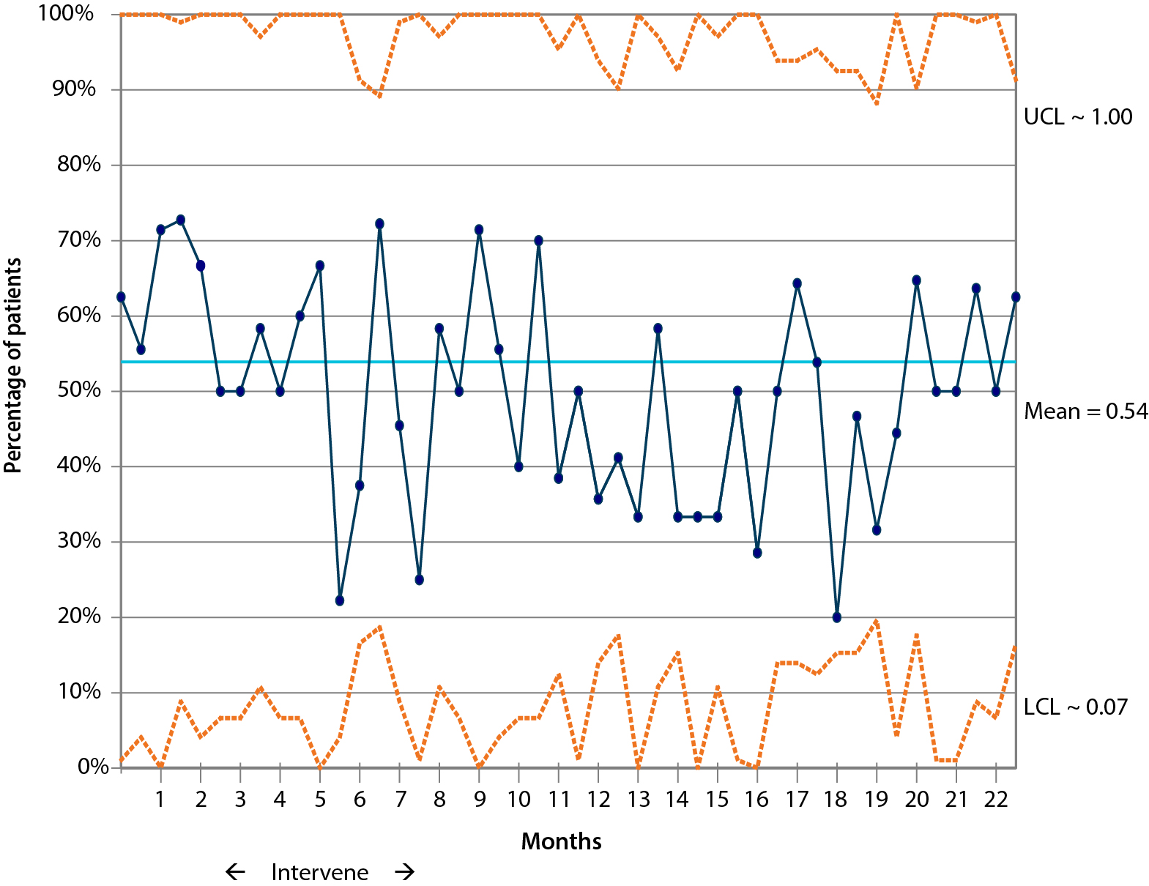
QI Workshop 4 — Data

Foot examination once during year

